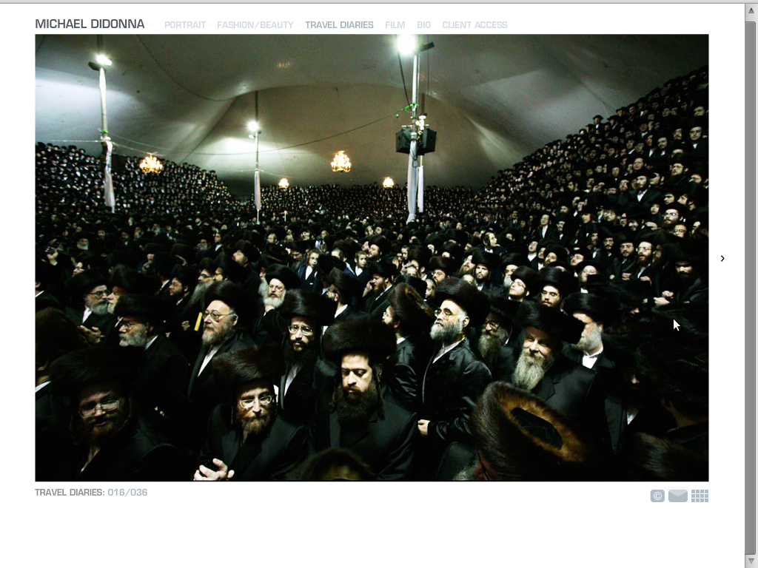

This photo, taken by Michael Didonna is really striking. I like the use of the existing lighting to light up the people's faces, but their clothes almost seem to blend into one another to make it feel like there is only one subject, when in reality there are hundreds, possibly thousands. The convex curved roof and the concave seating that the people are in almost makes an impression of the crowd going on forever and disappearing into the curvature of the earth. My imagination also took over and made me think of the crowd of people as a wave in the ocean, flowing in waves and leveling out as they reach you standing on the shore.